**An unhandled exception occurred Rendering Controller Error - Sitecore 8.2**

This error is an interesting one because there are a few different reasons. My case was not what the error actually says.

**Error in experience editor**

[cc lang="text" tab_size="4" lines="-1" theme="mac-classic" line_numbers="false"]

[/cc]

I first observed this error in the experience editor in the controller rendering component. I googled a lot and tried out different solutions thinking the issue was to do with my controller.

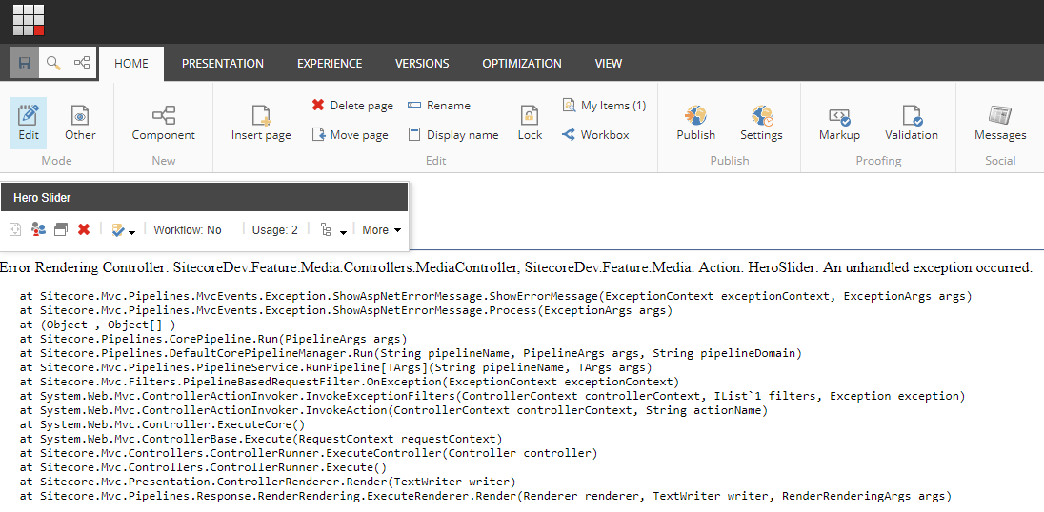

Then, I thought about publishing everything and see how it looked in the actual website. This turned out to be a good move. I finally realised the error was nothing to do with my controller.

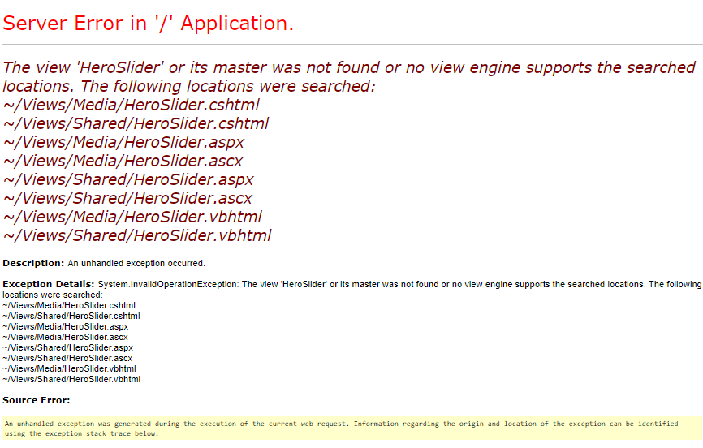

**Solution**

The solution is simple from the error seen from the actual website. The root cause was publishing action was not publishing cshtml in the right folder. When I went to the View folder in the web root folder, I saw the file was not in Shared or Media folder.



The quick fix was to create a Media folder and move cshtml into it. The long term solution would be to fix the publishing process so that the cshtml gets placed in the right location.

